No | Answer
Na : B : O
Mole ratio 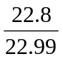 : 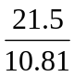 : 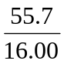
0.9917 : 1.989 : 3.481
1 : 2.006 : 3.510
2 : 4 : 7
Empirical formula is Na₂B₄O₇.
C : H : O
Mole ratio 0.0556 : 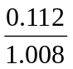 : 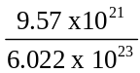
0.0556 : 0.1111 : 0.01589
3.499 : 6.992 : 1
(×2) 6.998 : 13.98 : 2 ≈ 7 : 14 : 2
Empirical formula is C₇H₁₄O₂.
As : O
Mole ratio 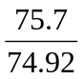 : 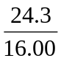
1.010 : 1.519
(×2) 2.02 : 3.038 ≈ 2 : 3
Empirical formula is As₂O₃.
Formula mass = 197.84 MF is (As₂O₃)_{a}, where a = 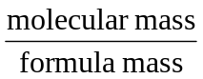 = 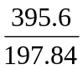 ≈ 2
Molecular formula is As₄O₆.
 | It absorbs water formed in the reaction.
 | It absorbs carbon dioxide formed in the reaction.
m(CO₂ formed) = 43.54 g n(CO₂) = 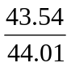 = 0.9893 = n(C in hydrocarbon)
m(H₂O formed) = 22.26 g n(H₂O) = 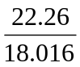 = 1.236
n(H in hydrocarbon) = 1.236 × 2 = 2.471
C : H
Mole ratio 0.9893 : 2.471
1 : 2.498
(×2) 2 : 4.996 ≈ 2 : 5
Empirical formula is C₂H₅.
 | The sample must vaporise at a temperature below that of the steam (below 100°C).
PV = 8.315 nT n(gas formed from liquid) = 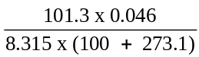 = 0.001502 mol
M(liquid) = 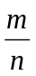 = 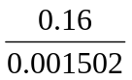 = 107 g mol^{–1}
m(C) in sample = 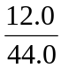 × 27.83 = 7.590 g
m(H) in sample = 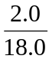 × 11.38 = 1.264 g
m(O) in sample = 18.99 – 7.590 – 1.264 = 10.14 g
C : H : O
Mole ratio 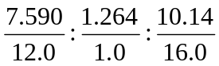
0.633 : 1.264 : 0.634
1 : 2 : 1
Empirical formula is CH₂O.
M = 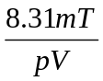 = 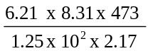 = 89.99 g mol^{–1}
EFM = 30 MF is (CH₂O)_{a}, where a = 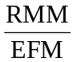 = 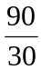 = 3
Molecular formula is C₃H₆O₃.

